

**Minutes Of The Meeting (PRE BID MEETING)**

A Pre-Bid meeting was held today (22/10/2024) at State Life Building; Headed by Tender-Committee State Life Insurance Corporation of Pakistan, accompanied by Mr. Hissaan Awaiz (Architect & Consultant of the project) and MESA team Ms. Alina W. Mehta, Mr. Athar. A. Rizvi, Ms. Soha Jamshed. In the presence of all interested bidding contractors present (marked as attendance).

Mr. Hissaan from MESA started the meeting with a briefing at 11:00am covering the project design, plan, timelines (Floor wise), and start of execution of the project up to the completion period of 18months.

A comprehensive Question & Answer session was held after the briefing to entertain all of the technical and financial queries leveled up by the bidding contractors. Questions mentioned below were raised by bidding-contractors:

Questions and Response during Prebid meeting along with recommendation to SLIC.

1. Q: Bank Guarantee to be replaced by Insurance Guarantee for the project:

A: We need to comply with existing regulations ~~EPADS.~~ We are sorry we cannot entertain this proposal.

1. Q: Request for cut down of Bid security Amount.

A: The Bid security is within the prescribed limits ~~close to the lowest value of EPADS criteria,~~ we will not be able to reduce it further.

1. Q: Minimum IPC is 10%, contractors asked for fixed value or reconsideration.

A: The project is 18 months undertaking. We would like to see more of work to be commenced on site. Therefore, a minimum 08% (eight percent) IPC is being requested. State life is recommended to consider the 8% Minimum bill for the bidder to ensure a smooth cash flow.   
SLIC: (To Respond)

1. Q: Early Payment or Running payment before 30 days period.

A: No change to be made to the payment days. State life has shown its commitment to make sure all perfectly cleared bills are escalated in between 2-4 weeks.

1. Q: Revision of Bid Security Amount, if possible.

A: Please check comment for part 2.

1. Q: Increase in mobilization advance amount.

A: Mobilization amount may be retained as per tender.

1. Q: Price adjustment under clause 17 for electrical wires and escalation factors.

A: For copper wires cross sectional area shall be taken into consideration to determine the escalation factors.

1. Q: Procedure of Termite proofing and billing accordingly.

To be measured in a single stage and to be claimed in IPC according to its stages as mentioned in BOQ.

1. Q: Brand clarification of Marine Ply to be used.

A: Patex or equivalent (material tests to prove equivalence in terms of density and chemicals used for binders) . We believe in open market and free trade.

1. Q: Brand Clarification of Cement Board to be used.

A: Elephant or equivalent

1. Q: Glass thickness to be used.

A: For Ground Floor; a double-glazed section of all tampered 12 mm outside 6 mm inside having a 12 mm vacuum gal. Shall be deemed sufficient with 3M bomb proof film on the outside glass and aesthetical glass frosting on the inside.

1. Q: Marble size, fitting structure, feature walls & Preliminary items list.

A: Contractors may consider RIO BLUE for Feature walls and Diagnose White Marble Texture

1. Q: Secured Advance clarification requested to what % Secured Advance be given as it is applicable in PEC and FIDIC Clause

A: Secured Advance has been made a part of tender. SLIC is requested to consider approving 75% Secured advance upon receiving on goods on site but the goods need to be in line with the overall construction programme to ensure space availability on site.   
SLIC: (Response Awaited)

1. Q: Extension in date of submission.

A: Bidders have been clarified that the project is ready to be executed; this is the second time the project is being floated due to lack of technically competent bidders. We are pressed on time. If SLIC feels a relaxation of 5 working days be given we will not be at a disadvantage.

SLICL (Response Awaited)

1. For all Gypsum and Cement board partition it is mandatory to introduce Flash gap of half an inch to separate each joinery plane. Specially in ceilings. Contractor must consider the cost of introducing flash gaps in ceiling members and where required.
2. Q: Please provide base prices for all items as mentioned in the BOQ since the items vary and it will be difficult to keep a competition in place.

A: The origins have been mentioned, sizes and complete specifications are a part of the tender documents. We encourage contractors to consider the walkthrough, compliance sheet and specification as a fair information provide. Submission of base prices will negate the open market practice as none of the material or its context is based on a schedule rate but open market assessment is required.

1. Q: Are bidders supposed to install their own infrastructure to undertake the project which means water and electrical connections?

A: The project is Infront of CM house; SLIC representatives have confirmed that state life will provide electricity and water and shall allow the contractor to connect to their infrastructure however a payment of consumption shall be made by the contractor. It is understood that the contractor shall install their own flow meters, electrical sub meters and calibrate it every quarter in presence of consultant’s staff, if the client is unavailable. We cannot afford to create a labour camp in the principal office. Work timings should remain as per contract.

1. Q: Can the engineering facilities be transferred to the client?

A: The Cost of engineering facilities needs to be absorbed in the contract. Please follow the Bidding documents. Mandatory requirement of the contract.

NOTE: There have been too many general queries for which MESA has already provided the intent of the tender vide an interactive walk through which can be used to visit each and every section of the place, elevations may be conceived from it; layout establishes the placement of all materials. In addition the compliance sheet lists all components ranging from plants, pots till last accessory items which need to be read in conjunction with the tender.

All of the above queries were professionally addressed and responded by Mr. Hissaan MESA, and their associates to all the participants present at the meeting. And upon satisfactory acceptance of all the answers made to the bidding contractors, the said meeting was concluded at 12:30pm on a good note for all the bidding contractors to follow all the rules and regulations of Client/PPRA and bid according to the specs & 3Ds provided. The consultant further advised the bidders to send in their written responses to be made a part of final MOMs as now it is only 9 days from the bidding dead line.

Technical Response to questions received vide emails:

1. All Block Masonry shall be 1000 psi in strength.
2. Lift Feature wall: Daignose White Book matched marble.
3. Lift Trims: SS of Suitable color with 2 mm gauge.
4. All trellis MS works for architectural features to be considered as ¾ th Square Sections with 14 gauge thickness to be dressed and colored as specified in description.
5. 14 mm – 18 mm : 2mm thickness section please find picture attached.

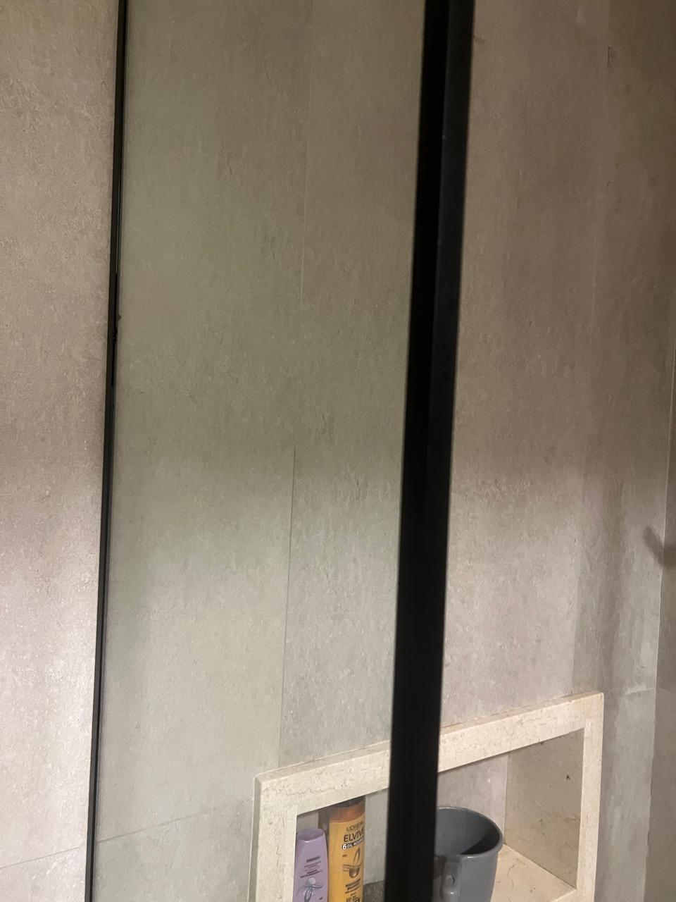

1. Aluminum Window: Please follow description: The sections, profile is mentioned. LOW E Glass outside 12 mm thick, 6 mm Thick Glass inside (All glass to be tampered) at least 16 mm vacum.
2. All Water proofing to be a quoted in Sft.
3. For item # 38,40 LED Pelmet Light: Light and its accessories is a part of the item. Connection vide electrical wire which is a part of the electrical boq.
4. ASH WOOD (Pre-Seasoned with Certificate) to be considered for all wood sections.
5. Signage, please allow yourself to follow the BOQ description.
6. HVAC: Ambient temperatures and HVAC positions have been clearly marked in the drawing set; To be informed the outdoors are located in a well-ventilated space with shading. Ambinet temperature +1 to 2 Degree may be considered. All VRF to be top discharge units to ensure optimal heat dissipation. The contractor may visit the site and acquantain themselves. Each VRF outdoor unit is in close proximity to each other and inner units if confined in one single place need to be connected to alternating Outdoor unit as described.
7. Corian: Please follow description and 3d we would like you to consider price of Dupont (Nug wood, Carbon Concrete, Cocoa Prima) and Montelli (Blizzard, Billi Berry, Bark) as per description.
8. DRY Type Transformer: Since EIK certificate is mandatory for the project; compliance as per KE standard is desired. We would like to work on options compliant with the electrical distribution company at the time of commission.
9. The heights of auditorium floor are already given and structural members need to be as described.
10. VRF equipment schedule is already provided in the bidding documents Pg # 392 onwards. Most of the manufacturers have already been consulted for the solution. OEM factory visit is to be deemed mandatory along with manufacturer’s storage visit to ensure compliance of 2 years maintenance.
11. Kindly quote for all quantities if any quantities is missed in the financials, it will be deemed having a numerical value of zero “0”.
12. For Hardware of wooden and glass door please follow the specifications.

Confirmed and signed for recommendation to SLIC:

1. Muhammad Hissaan Awaiz (Principal Architect)